**Notice of Formal Meeting**

**ON-DEMAND PUBLIC MEETING**

**Town of Warren**

**__________________________________________**

**Intersection Improvements on Route 90 in Warren**

**Access to this and all other active meeting presentations is available at our Public Meetings Page located at** [**bit.ly/mainedot-meetings**](https://bit.ly/mainedot-meetings)

MaineDOT will have an on-demand presentation available for this Formal Public Meeting. This meeting will give information about the proposed project, including a PowerPoint presentation and other pertinent information to help the public understand the project. These on-demand meetings allow for convenient viewing at any time. The meeting also provides the ability for online comments and questions that will be answered by MaineDOT staff.

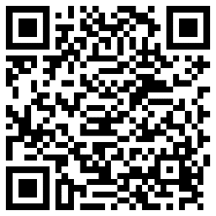

This public meeting is to inform and invite public comments. We are particularly interested in learning local views, discovering local resources, and identifying local concerns and issues. Anyone interested can view the presentation at the above website or scan the QR Code with their smartphone for access.

MaineDOT invites and encourages you to review the meeting and share your thoughts on this project during the formal comment period from June 13, 2025, to July 11, 2025.

Reasonable accommodations have been made to provide access to these meetings by providing access at any time within a two-week period. Additional accommodations to allow full participation in these meetings can be requested by contacting the Project Manager listed below. Please see the Accessibility/Accommodation document on our [Public Involvement Background Information Page](https://storymaps.arcgis.com/stories/8f175ebd865c4dd9ba55bcc15cfe3b3d) for more information regarding requesting accommodations.

Questions, comments, or inquiries can be made directly through the on-demand meeting or can be directed to the Project Manager listed below.

Martin Rooney, Senior Project Manager,

Maine Department of Transportation,

24 Child Street, 16 State House Station,

Augusta, Maine 04333-0016.

Telephone: (207) 446-0364

Email: martin.rooney@maine.gov

**Work Identification Number 027036.00**